COMHAIRLE CONTAE AN LONGFOIRT

LONGFORD COUNTY COUNCIL

Corporate Affairs,
Aras an Chontae,
LONGFOIRT.

24th October 2014.

To: The Cathaoirleach, Members of Longford County Council and Oireachtas Members of Longford/Westmeath Dail Constituency

A Chomhairleoir,

You are invited to attend a Special Meeting of Longford County Council to be held in the Council Chamber, Aras an Chontae, Great Water Street, Longford on Monday 3rd November 2014 at 6.00 p.m. to consider the ongoing financial crisis at St. Christopher’s Services, Longford.

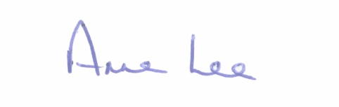
Mise le meas,

Anne Lee
Meetings Administrator.

